ER Model to Tables
Refer to the given ER Diagram (School Management System).
Entities:
Student (RollNo, Name, Email, phone_no, Gender, Age)
Course (CourseID, Title, Credits)
Teacher (TeacherID, Name,phone_no , Subject)
Enrollment (RollNo, CourseID)

Relationships:
Student ENROLLS in Course
Teacher TEACHES Course
Answer: -
Link: -
E - R Model3.drawio.svg
E-R Diagram3.drawio.svg

1: Draw the ER diagram in your notebook (or use online tool): -
Convert ER model into SQL tables with proper constraints: -
-Primary Key (PK)
-NOT NULL, UNIQUE, DEFAULT constraints
-Appropriate Data Types
Answer: -
Student
Rollno | int | Primary Key
Name | Varchar(50) | Not Null
Email | Varchar(50) | Unique
Phone_no | int | Not Null
Gender | Varchar(50) | ENUM('Male', 'Female', 'Other')
Age | int | Not Null
Course
CourseID, | int | Primary Key
Title | Varchar(50) | Not NULL
Credits | Varchar(50) | Not NULL

Teacher

Teacher_id | int | Primary Key
Name | Varchar(50) | Not NULL
Phone_no | int | Unquie
Subject | Varchar(50) | Not NULL

Enrollment

Rollno | int
Course_id | int

2: Create and Insert Data
- Create all 4 tables (Student, Course, Teacher, Enrollment).
- Insert:
At least 5 Students
At least 2 Teachers
- Insert at least one student with NULL Age (test NULL handling).
- Try inserting duplicate RollNo and Email → note the error message.
Answer: -
Student
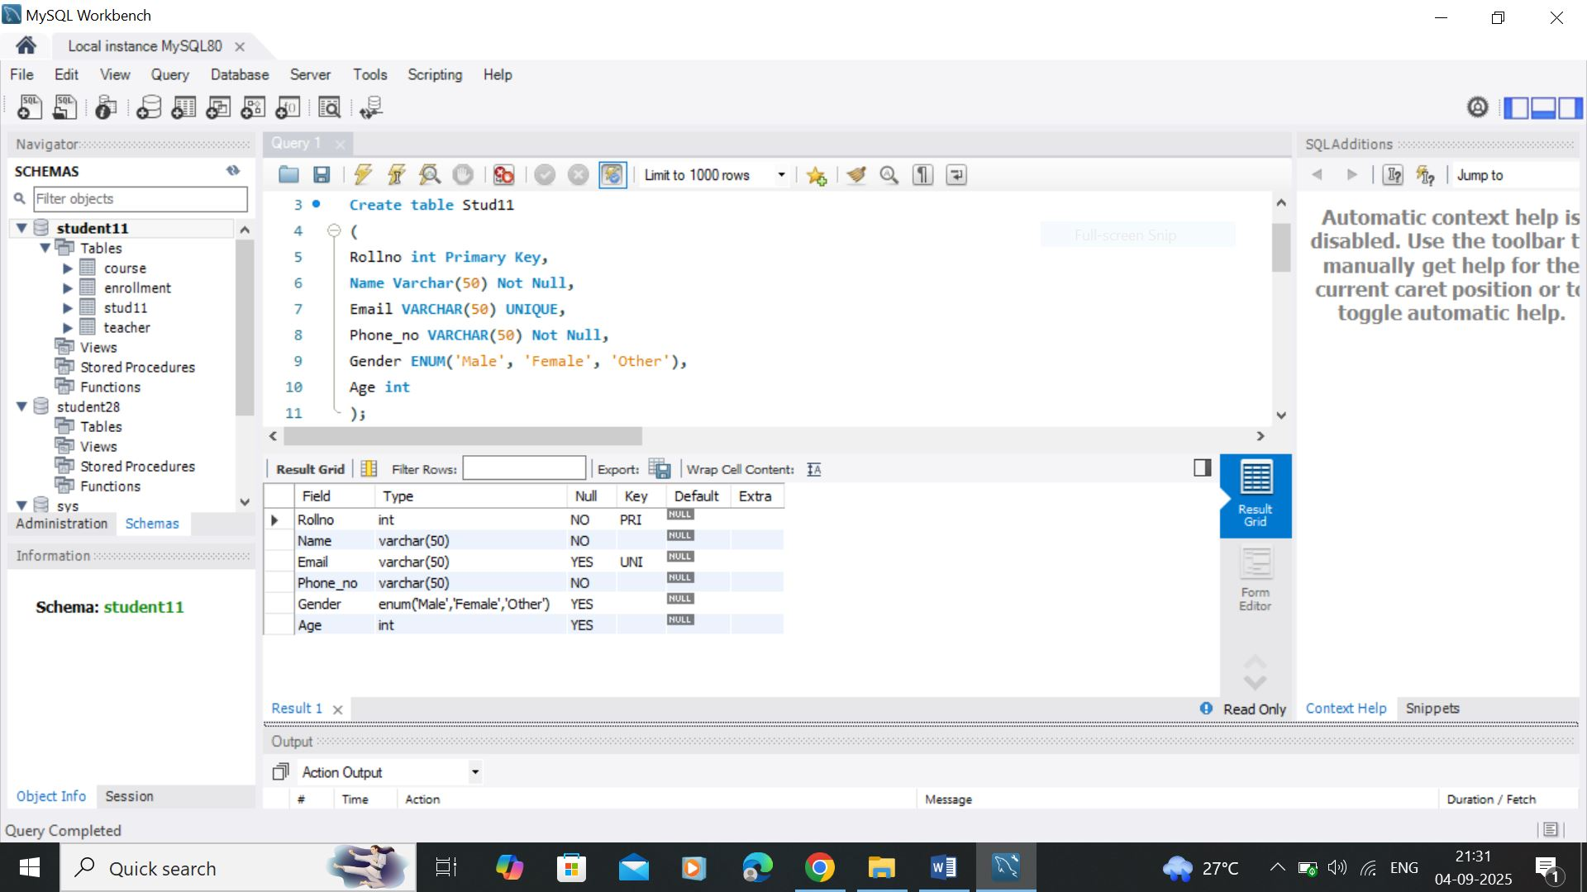
Course
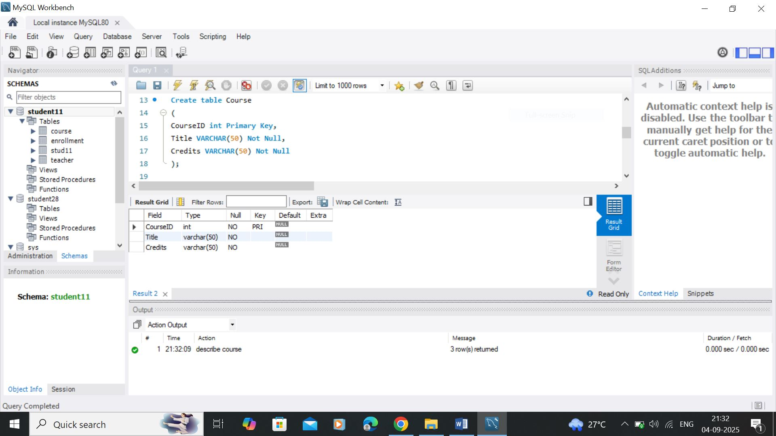

Teacher
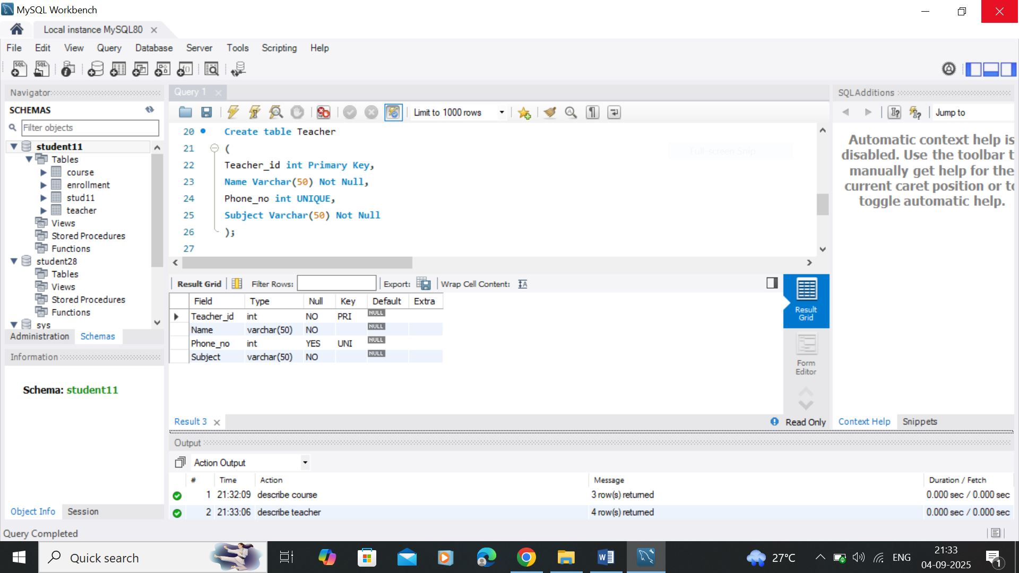

Enrollment
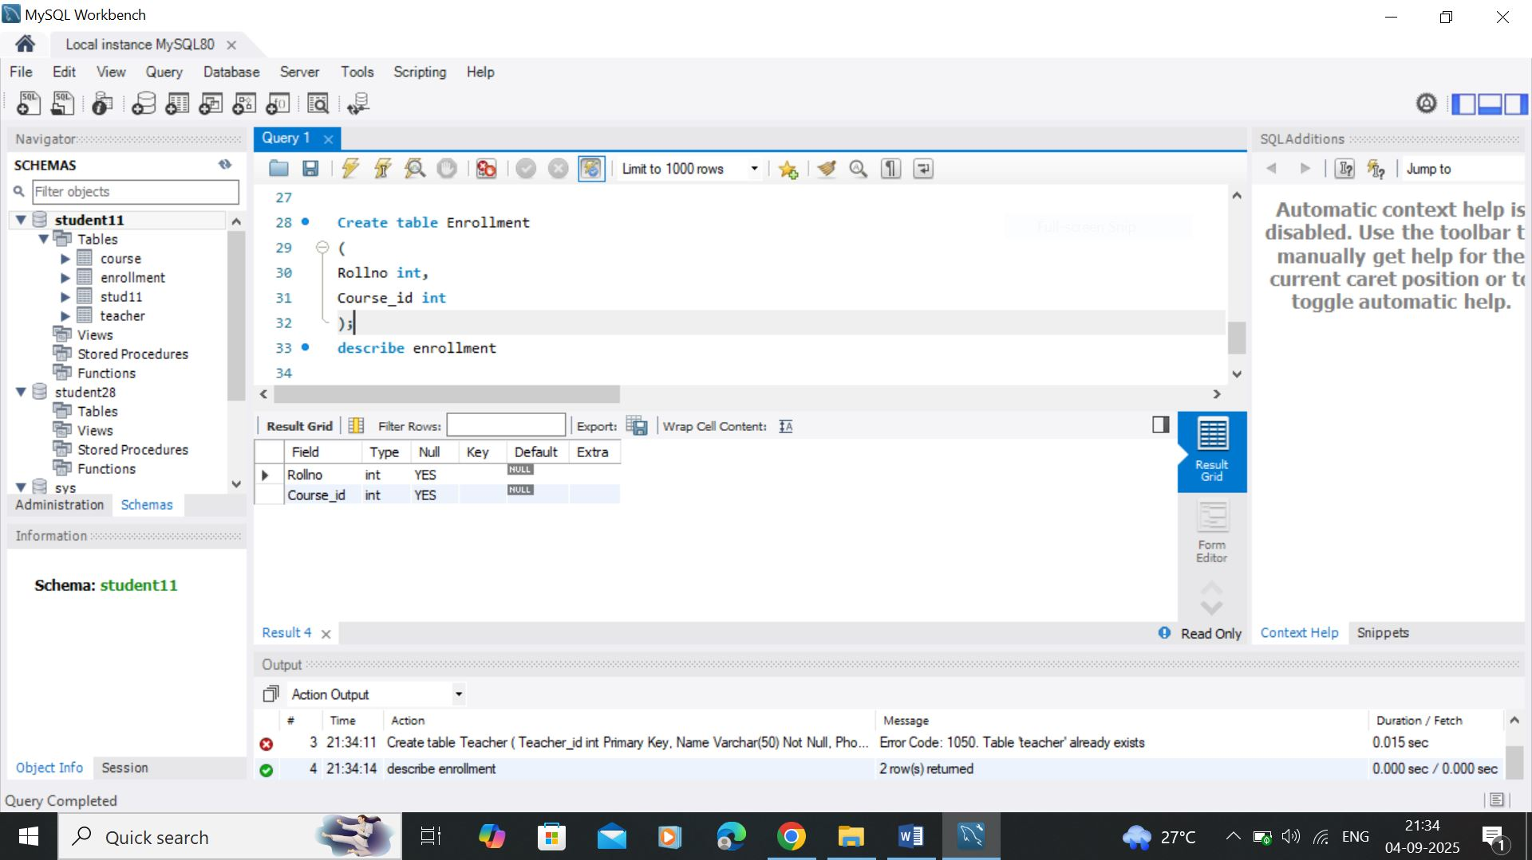

3: Select Queries (DQL)
- Show all students (SELECT *).
Answer: -
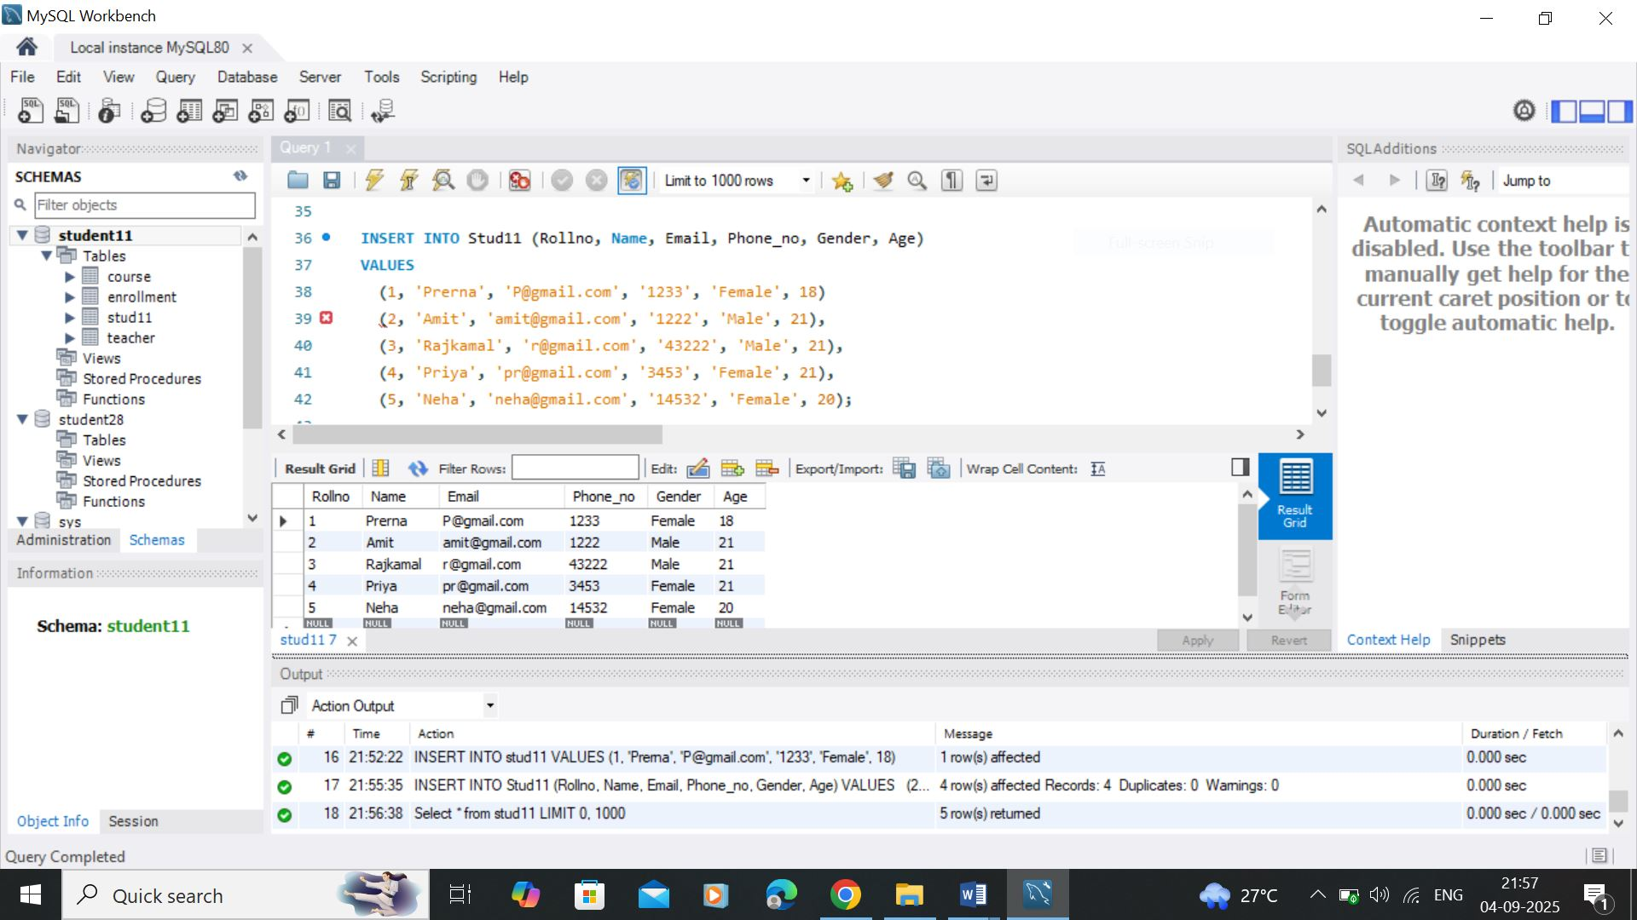

- Show only Names and Emails.
Answer: -
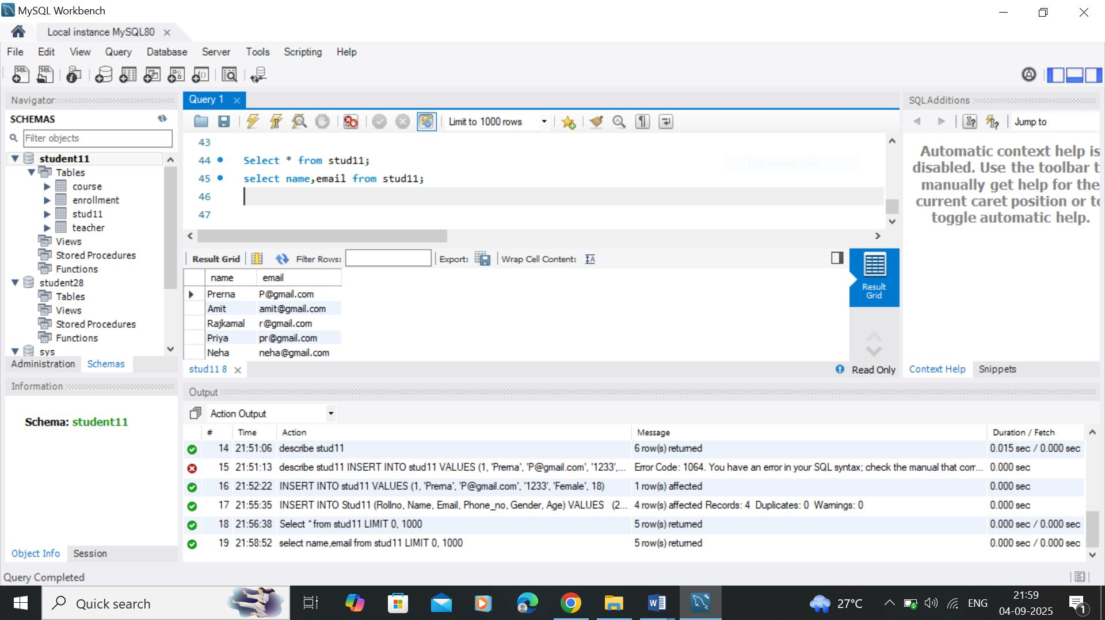

- Use aliasing: Show Name as StudentName and Email as ContactEmail.
- Show Enrollment details (RollNo, CourseID).

